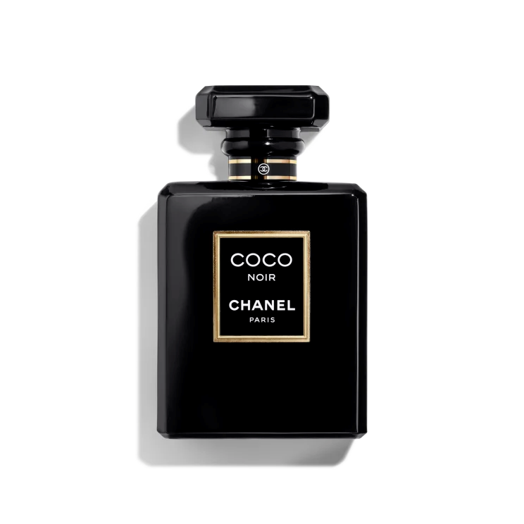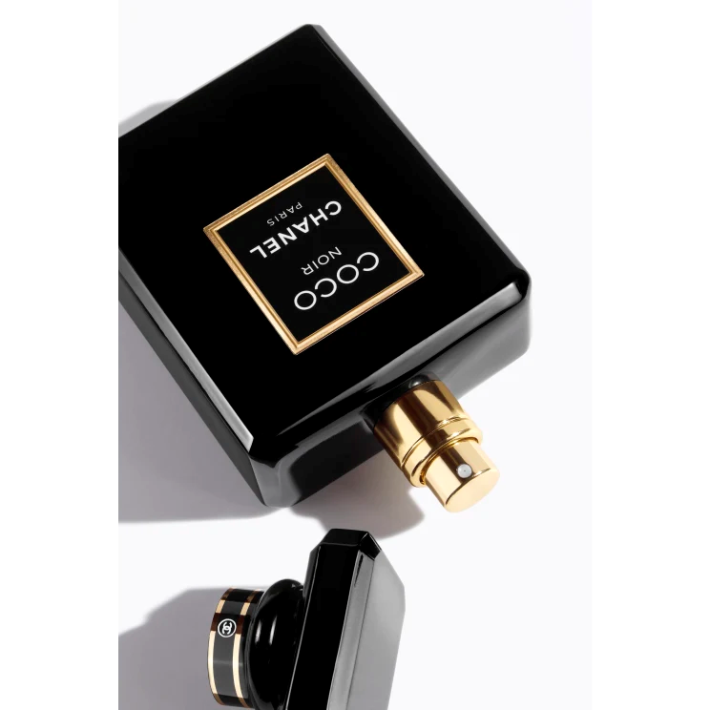

COCO NOIR

**$165**

Tax Included.

Spray 100 mL

IN STOCK

**Product Details**

CHANEL has always entrusted black with an essential role: to highlight a woman. COCO NOIR celebrates this paradox and incarnates the iconic shade by using a deep black to bring a dazzling femininity to light.

Intimate, seductive and intensely brilliant, COCO NOIR is a contemporary expression of magnetic sensuality told in a modern ambery fragrance.